NXT ROBOTICS
LEGO Mindstorms NXT is a kit containing programmable robotic parts released by LEGO in late July 2006. The Mindstorm NXT is an upgrade from the orginal first generation LEGO Mindstorm kit made in 2001, which was called and known as the Robotics Invention System. The Mindstorm NXT kit contains many more advancments from the orginal edition. The parts included are in the picture below (Picture 1). Compared to the old Robotics Invention System kit, this was considered revolutionary for the younger generation of future engineers. In my PBL project I worked on different designs and programming. You may find more information by following the QR codes.
Robot Parts | NXT Robot
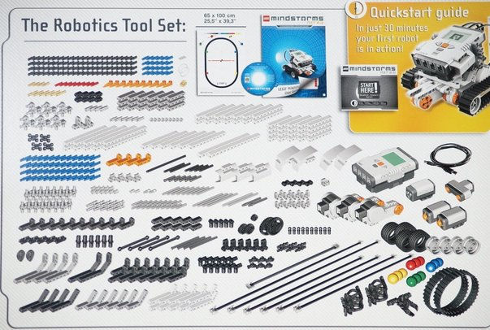 | 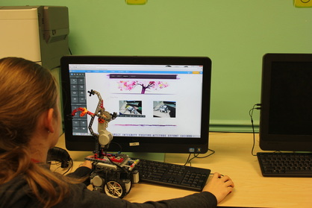
NXT Spider | Door Alarm
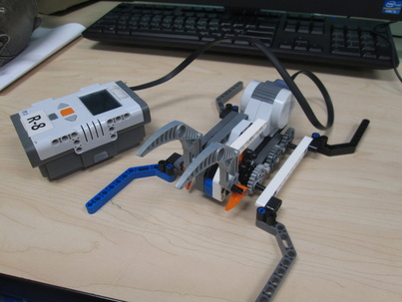 | 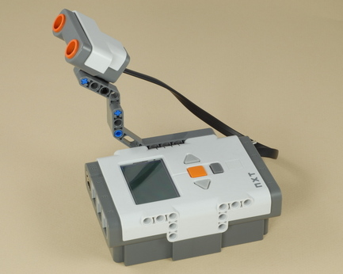
My Video |  | My Website
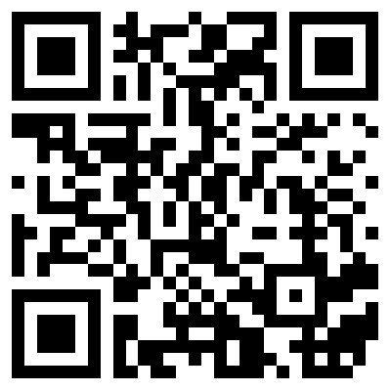 |  | 